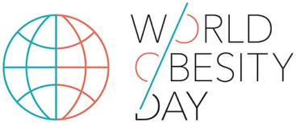
Insert your logo here

[insert address]

11th October 2017

Dear [Health Minister],

[Country]’s commitment to ……

The World Health Organisation has recently reported that an escalating global epidemic of overweight and obesity is taking over many parts of the world. If immediate action is not taken, current trends suggest that by 2025 over 2.7 billion adults worldwide will suffer from overweight and obesity. In [your country] it is estimated that XX% adults will be living with obesity in 2025.
On 11th October, World Obesity Day 2017 focuses on the urgent need for investment in services for the prevention and treatment of obesity. To mark this day, we urge you to increase investment in tackling obesity now to avoid the consequences later.
Untreated, obesity is responsible for significant proportion of non-communicable diseases including heart disease, diabetes, liver disease and many types of cancer. The worldwide costs of treating these diseases in 2014 were US$1684bn and obesity is directly responsible for US$600bn of these costs. If we don’t take urgent action to treat and prevent obesity, the annual global medical bill for treating the consequences of obesity is expected to reach US$1.2 trillion per year by 2025.
To put this in context, the annual medical costs of treating the consequences of obesity in [country] is estimated to rise from XX in 2017 to XX in 2025. The cumulative cost of not treating and preventing obesity over these years is an estimated XX. In contrast, by spending XX on tackling obesity now, obesity prevalence in [your country] could be reduced from XX to XX which would significantly cut these medical costs.
We hope to raise awareness of the cost-savings for countries like [country name] by treating obesity now compared to treating the co-morbidities later and invite you to join us in supporting World Obesity Day 2017. Please visit www.obesityday.worldobesity.org for more information.
Yours sincerely,

[insert your name]

Professor Ian Caterson
President, World Obesity Federation

